Mission 11:
Spirit Level

Student Workbook





Let’s level up!

In this project you’ll build a spirit level! This is more than just a fun project – it’s a useful tool with practical applications.

Go to the Mission 11 Log and fill out the
Pre-Mission preparation.
- Your cell phone can detect if it is level or tilted. What other devices use some kind of sensor to determine their orientation?

Mission 11: Spirit Level
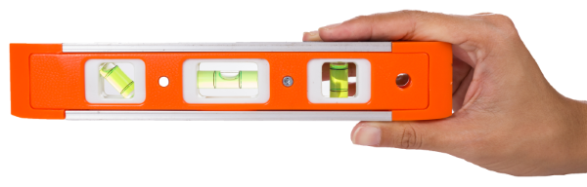
How level is your desk or table?
Write some code to find out. During this project you will build a spirit level.

Project Goals:
- Display a numeric "tilt" value from the accelerometer.
- Scale the raw tilt value to show 0° to 90° incline.
- Replace the number display with a graphical ball simulation!

Mission 11: Get started
- Go to https://make.firialabs.com/ and log in.

- Go to Mission 11

- Click and start Mission 11.

Objective #1: Accel
This mission will use CodeX’s built-in accelerometer
- What is an accelerometer?

- Click on
- Go to the Mission Log and answer the question.

- Return to the digital instructions.
- Go back to the Mission Log and answer the question.

Objective #1: Accel
DO THIS:
- Close the instruction panel
- Use the camera controls to zoom in
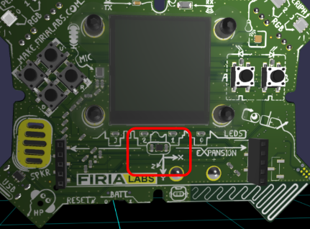
- Click on the accelerometer
- Create a new file named Spirit_Level

Objective #2: Tilt-o-Matic

When you read the accelerometer, it returns three values, one for each axis.
- The three values are enclosed in parenthesis:
(x, y, z)
- This type of data is called
a tuple.
- Other tuples:
  - Color values: (red, green, blue)
  - Location on a grid: (x, y)
To read the accelerometer, use this code:
val = accel.read()
A tuple is a special kind of list. You can get
specific x, y or z values like items in a list:
tilt_x = val[0] # first value is at index 0
tilt_y = val[1]
tilt_z = val[2]

Objective #2: Tilt-o-Matic
This mission will use CodeX’s built-in accelerometer
- Go to the Mission Log and answer the questions about data from the accelerometer.

DO THIS:
- Read the accelerometer
- Display the x value
- Delay a short time to read the display
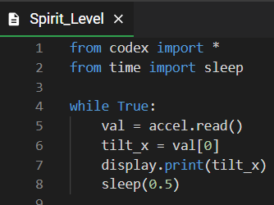
- Your code could look like this:

Objective #3: Scale to Degrees
- The numbers you see on the display are all over the place.
- We usually measure angles in degrees.
- You need to convert the raw data -- numbers you see on the display -- into degrees.
- This involves some complicated math -- trigonometry -- so use the code given and don’t worry about the actual math.

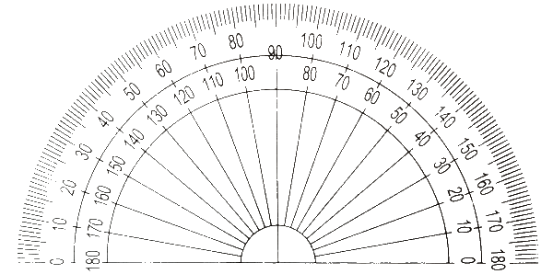

Objective #3: Scale to Degrees
DO THIS:
- Import the math module
- Add the code as shown
- Change the display.print to show degrees
- Run the code
  - Can you get CodeX level,
with 0 degrees?
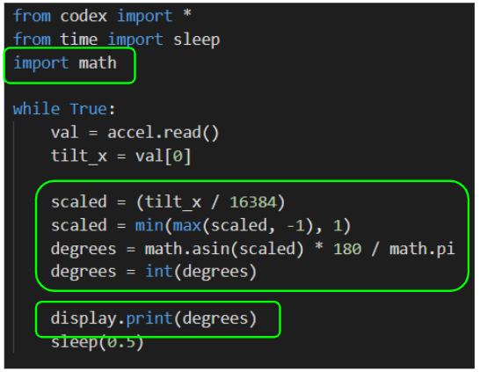
- Go to the Mission Log and answer the question

Objective #4: Static Ball
Time to learn a little about drawing on the display
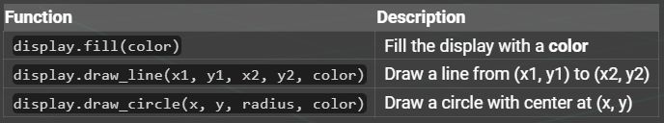
Here are the drawing functions you will use for your spirit level:

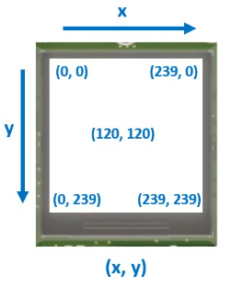
Concept: The display
The CodeX LCD display is
240 pixels x 240 pixels
- Each tiny pixel works JUST like the 4 RGB LED pixels at the top of the CodeX.
- x in the (x, y) is the display width
- y is the display height

Objective #4: Static Ball
DO THIS:
- Define a value for the center of the display
- Type the code to draw a line in the center
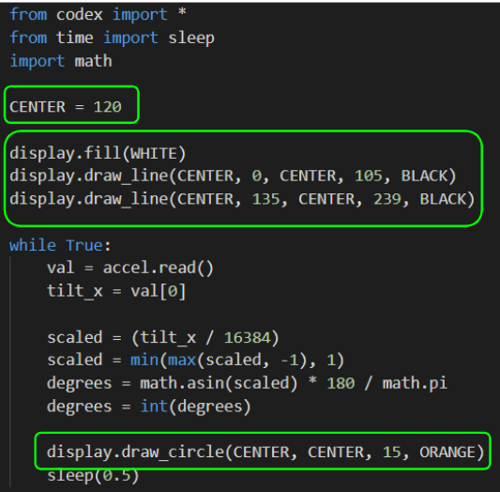
- Change the display.print() to drawing a circle instead

Objective #5: Rolling Stone
Time to make that ball move
- Use the information you have:
  - Center of display
  - Degrees for x
- Use math to calculate the position of the circle
- Use a variable for the data


Objective #5: Let’s Keep Playing
DO THIS:
- Define a value for the x position
- Assign it the value:
  - x = CENTER + degrees
- Use the variable in the draw_circle() command
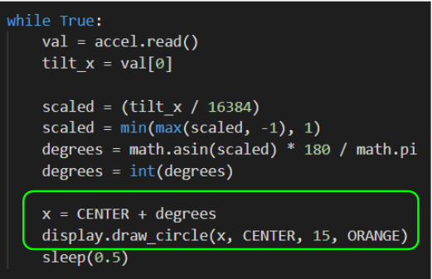
- Run the code and tilt CodeX to see the ball move


Mission Quiz: Accelisplay
Test your skills by taking the quiz.
Objective #6: Eraser First
Spirit Level -- final touches
- Why is the ball drawing on top of itself?
- Because you are not erasing it first.
- Cover your tracks!
- Draw a white circle to “erase” the current circle before moving to a new position and drawing a new orange circle.



Objective #6: Reduce Repetition
DO THIS:
- Define the x variable above the while loop
- Draw a white circle before calculating a
new x value
- Run your program
Does it work correctly?
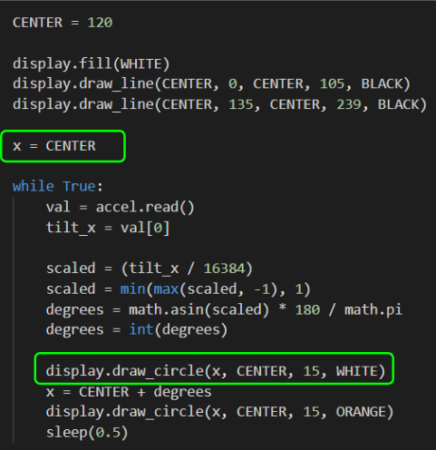

Mission Complete
You have completed the eleventh mission.
Do this:
- Read your “Completed Mission” message
- Complete your Mission 11 Log
  - Post-Mission Reflection
- Get ready for your next mission!

Wait! Before you go … Clear the CodeX
Go to FILE -- BROWSE FILES
Select the “Clear” file and open it
Run the program to clear the CodeX
Okay. Now you can go.

